Sri Lanka Technological Campus
Praxis II (EME 104)
Batch 7 Semester 2

PROJECT REPORT

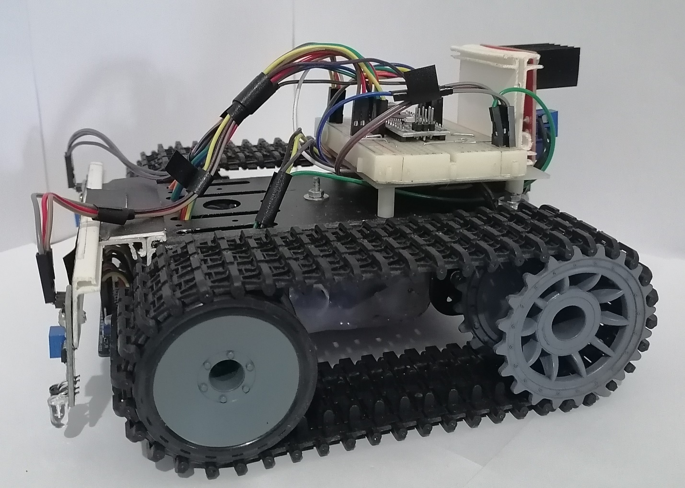

LINE FOLLOWING ROBOT
A 1st year project report submitted in fulfilment of the requirements for the degree of Bachelor of Engineering mechatronic Engineering.
Name | KEERTHI P.E.D.S.
Register number | AA2176
Email | keerthipe@sltc.ac.lk
Degree programme | Bachelor of Engineering mechatronic Engineering.
Report date | 11.03.2021

Approved by:
- Project Supervisor

--------------------- ------------------------------ ---------------------
(Signature) (Name) (Date)

- Head/In-Charge of the Department

--------------------- ------------------------------ ---------------------
(Signature) (Name) (Date)

Table of Contents

ABSTRACT
ACKNOWLEDGEMENT
LIST OF FIGURES
LIST OF TABLES,GRAPHS
CHAPTER 1
1.1 Introduction
1.2 Background
1.3 Motivation
1.4 Objectives
CHAPTER 2
2.1 Including hardware
2.2 Block diagram
2.3 Circuit diagram
2.4 About the grid
CHAPTER 3
3.1 Mechanical behavior
3.2 Control mechanism
3.3 Controller and software
3.4 Testing methods of prototype

CHAPTER 4
4.1 Conclusion
4.2 Future improvements
4.3 Risk and challenges
CHAPTER 5
5.1 Picture of Line Following Robot
5.2 Cost Estimation
5.3 References

APPENDICES

ABSTRACT

Line Following is one of the most important aspects of robotics. A Line Following Robot is an autonomous robot which is able to follow either a black line that is drawn on the surface consisting of a contrasting color. It is designed to move automatically and follow the line. The robot uses arrays of optical sensors to identify the line, thus assisting the robot to stay on the track. The array of eight sensor makes its movement precise and flexible. The robot is driven by DC gear motors to control the movement of the wheels. The Arduino nano interface is used to perform and implement algorithms to control the speed of the motors, steering the robot to travel along the line smoothly. This project aims to implement the algorithm and control the movement of the robot by proper tuning of the control parameters and thus achieve better performance. can be used industrial automated equipment carriers, small household applications, tour guides in museums and other similar applications, etc.

ACKNOWLEDGEMENT
We wish to express our profound and deep sense of gratitude to Ms. Upeksha chathurani, Project Co-ordinator, Department of Electrical and Electronics Engineering for sparing her valuable time to extend help in every step of our project work. We whole heartedly express our thanks to, Ms. Warunika Hippola, Project Supervisor, Department of Electrical and Electronics Engineering, for sparing time to go through every tiny detail and give her valuable suggestions to make this project and report a success. We are mainly indebted to the authors of many references and articles which were used as the reference. Last but not the least we would like to thank our friends and family for their help in every way for the success of this project report.

LIST OF FIGURES

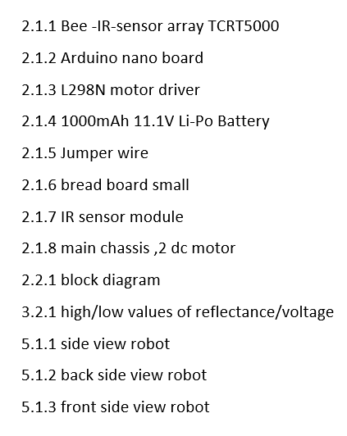

LIST OF TABLES,GRAGHS
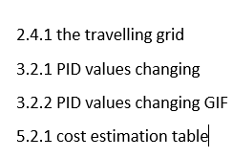

CHAPTER 1

  - Introduction
A mobile robot is to be designed and prototyped with the ability to follow a line, locate payloads, pick up and place the payloads and deliver the payloads to a designated location. The design is to simulate the use of handling robots in a real factory / production environment.
The project has been taken separately as the following list of tasks for the final product to accomplish.

  - Background
As technology becomes increasingly important in today's world, it is invaluable to not only learn how to use technology, but also to understand how to create it. Since being the engineer one should have sound knowledge of the other discipline. Most of the projects have limted scope to only specific discipline. This would limit ones innovation and creativity. This project inspires to make connections across several disciplines rather than learning topics in isolation as it combines mechanical, electronic, electrical and programming skills.
- It gives visual grasp of math and science.
- It builds logical thinking.
- It brings out innovation and creativity.
- It enhances problem solving skills.

  - Motivation
How ants always travel in a line, following ani n visible route in search of food, or back home. How on roads the lanes is followed to avoid accidents and traffic jams. Ever thought about a robot which follows line? A perfect or near perfect mimic of nature? After all the purpose of robotics is to recreate in terms of machines what one see around to solve a problem or fulfill a requirement.
The area will be benefitted from the project,
- Industrial automated equipment carriers
- Entertainment and small household applications.
- Tour guides in museums and other similar applications.
- Second wave reconnaissance operations.

  - Objectives
  - The objectives of the project are:
  - The robot must be capable of following a line.
  - It should be capable of taking various degrees of turns.
  - The robot must be insensitive to environmental factors such as lighting and noise.
  - It must allow calibration of the line’s darkness threshold.
  - Scalability must be a primary concern in the design.
  - The robot must be get 5 possible locations.

CHAPTER 2

  - Including hardware
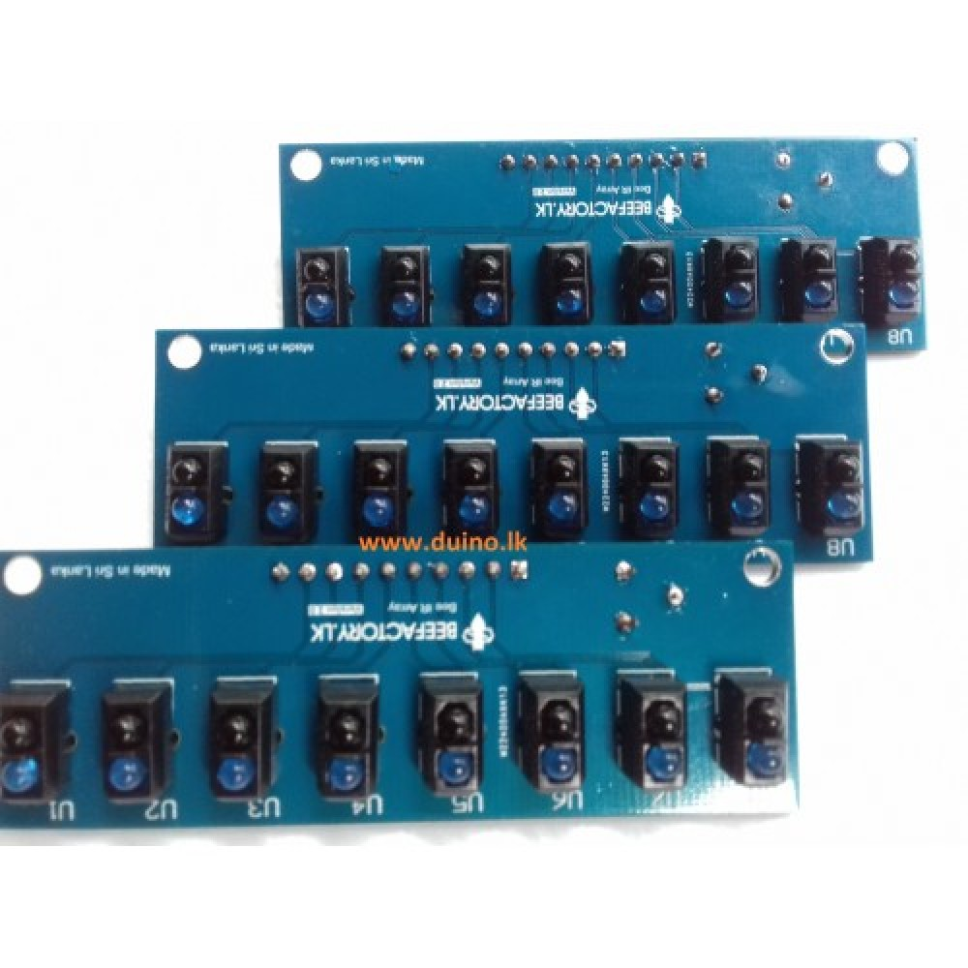
- Bee-IR-Sensor-Array-TCRT5000

2.1.1 figure.
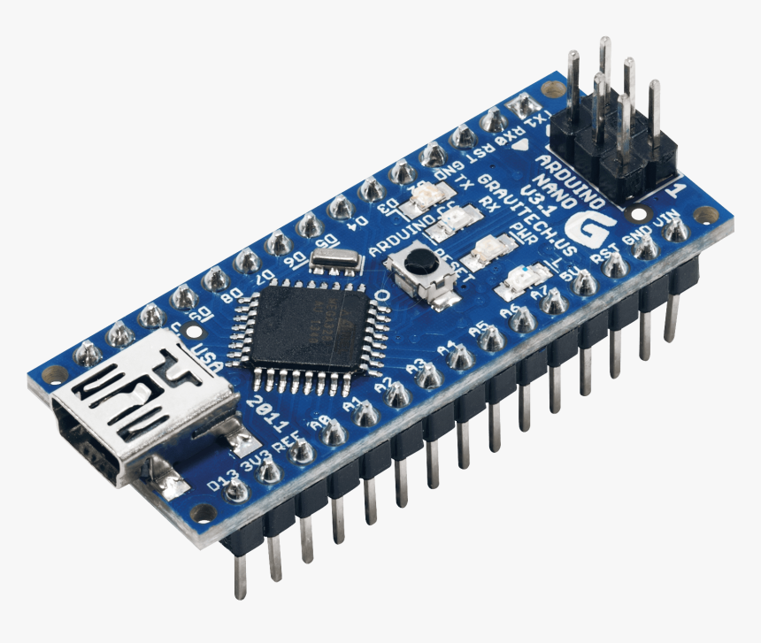
A sensor which includes an infrared emitter and phototransistor in a fixed package which blocks visible light. In this case, a sensor array is used to identify black lines on a white surface and the obstacles take place on the given grid.

- Arduino nano board

2.1.2 figure
This kit is operating by a specific program and can be powered by a USB connection or external power supply. This is the main part which is required to give instructions and signals for mechanical parts and other circuits of the robot

- L298N Motor Driver

2.1.3 figure
L298N is an integrated monolithic circuit which have the ability to operate DC motors according to a specific Instructions given by the microcontroller.

- 1000mAh 11.1V Li-Po Battery

2.1.4 figure
The Arduino mega development kit and the motor driver are powered by this battery
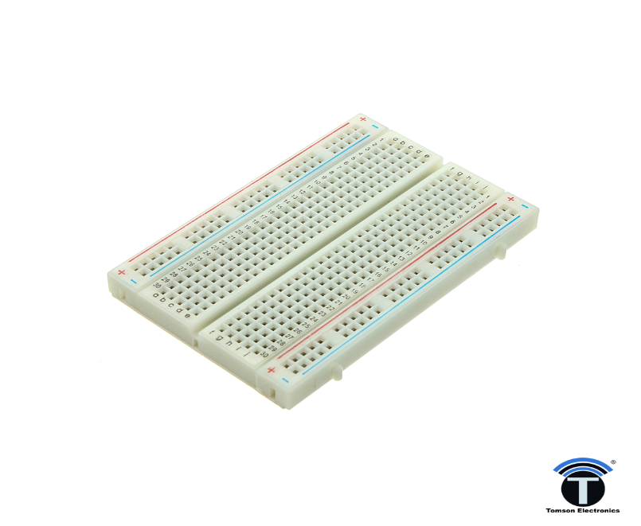
- Jumper Wires /bread board (small)

2.1.5 figure 2.1.6 figure

- IR Sensors

2.1.7 figure

- Main chassis with 2 dc motor

2.1.8 figure

  - Block diagram
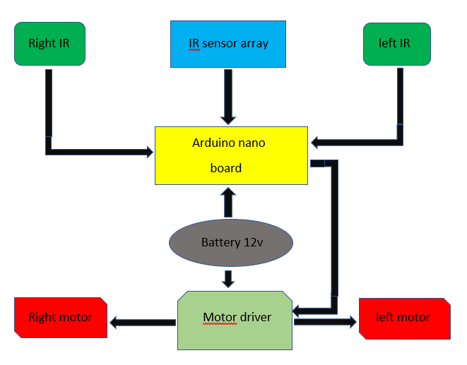

2.2.1 figure

  - Circuit diagram
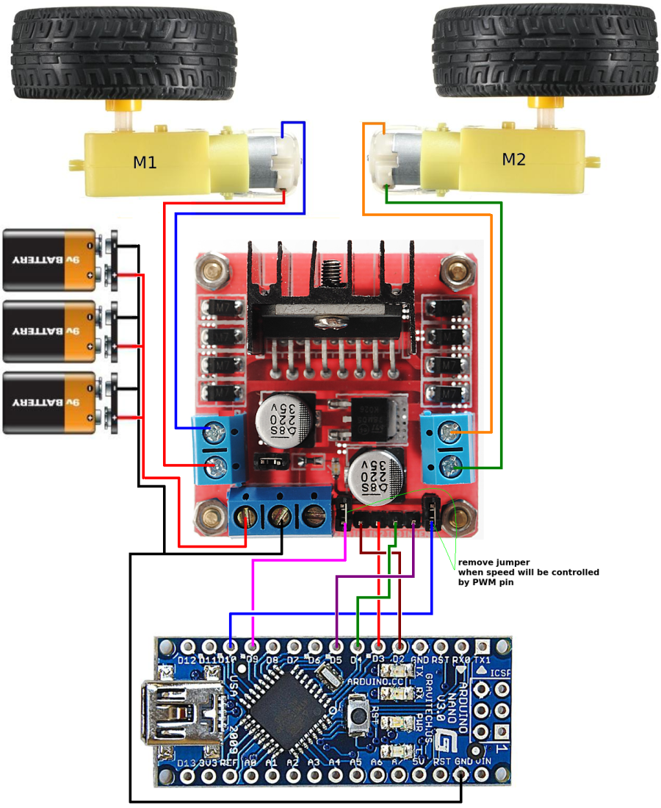

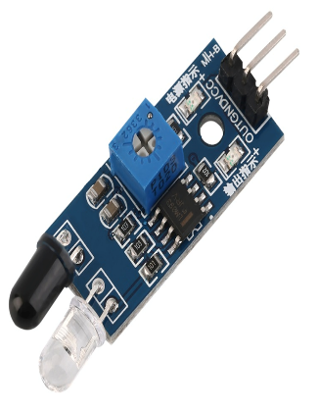
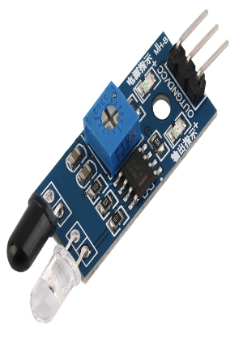

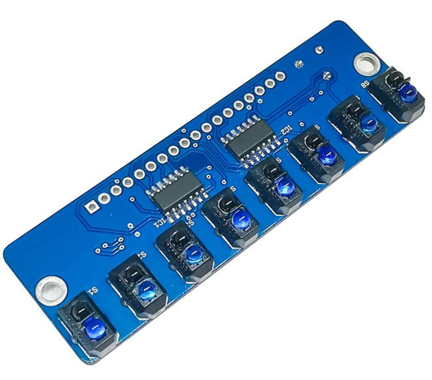

  - About the grid

2.4.1 grid
The grid consisted of black lines with 3 cm in with. Distance between two lines, L, is same for all the lines. Starting block and destination block are fixed and shown as black squares with 20 cm a side in Figure 1. At the destination, the robot should put the payloads into a basket where its opening is from a 20 cm height. The grid size will be 6 squares in length and 6 squared in width.

CHAPTER 3
3.1 Mechanical behavior
This robot consisted of two chain tracks, and each chain tracks can be driven independently either forward or backward. Further the robot has the ability to turn by the variation of the "chain tracks" speed and direction in traversing the grid.
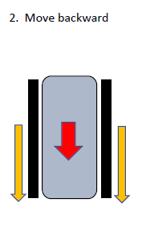
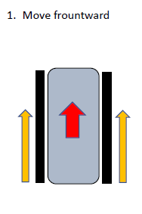

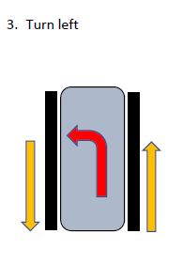
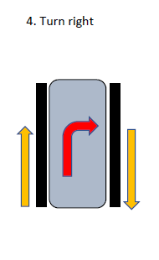

3.2 Control mechanism
- Behavior of TCRT5000 sensors in the sensor array

3.2.1 figure
Get “err” from sensor array and use that for controlling.
- PID controller theory
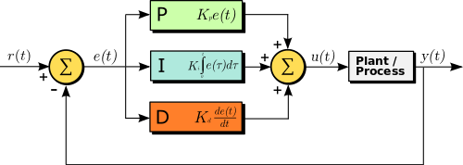
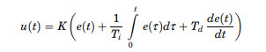

- PID controller theory (Graphs)
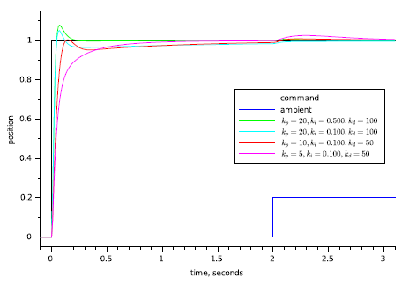

3.2.1 graph



3.2.2 graph

3.3 Controller and software
- Motor drive function
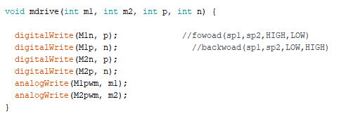

- PID function
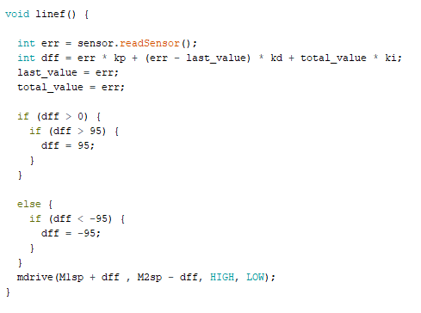

3.4 Testing methods of prototype

Upload code power on

Testing

Line following Turning

Tune sensor array Tune left/right IR

Not Following Following Turning Not turning

Check KD,KP,KI Test complete Check module
Check counter

CHAPTER 4
4.1 Conclusion
The line following robot is automobile system that has ability to recognize it’s path, move and change the robot's position toward the line in the best way to remain in track.
This project report presents a photodiode sensor- based line follower robot design of 1400gm weigh which always directs along the black line on white surface. The electro-mechanical robot dimension is 175×175×100 mm3 with max rpm 255 at no load and frictionless condition. The minimum turning radius for the system is 87.5mm at velocity of 160. The robot is able to detect it’s path in case it is out of path.

4.2 Future improvements
In the process of development of the line follower, most of the useful feature is identified and many of them was implemented. But due to the time limitations and other factor some of these cannot be added. So the development features in brief:
- Use of color sensor.
- Use of ultra-sonic sensor for better reconigsation and precise tracking the path.
- use the robot arm for Picking up payloads.

4.3 Risk and challenges
- tuning PID values (KP, KD, KI).
- turning 90 degrees.
- speed controlling.
- sometimes, sensors readings not correct as traveling is wrong.

CHAPTER 5
5.1 Picture of Line Following Robot
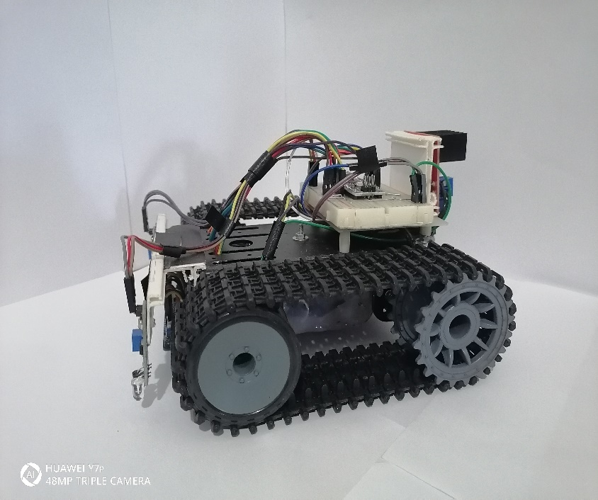
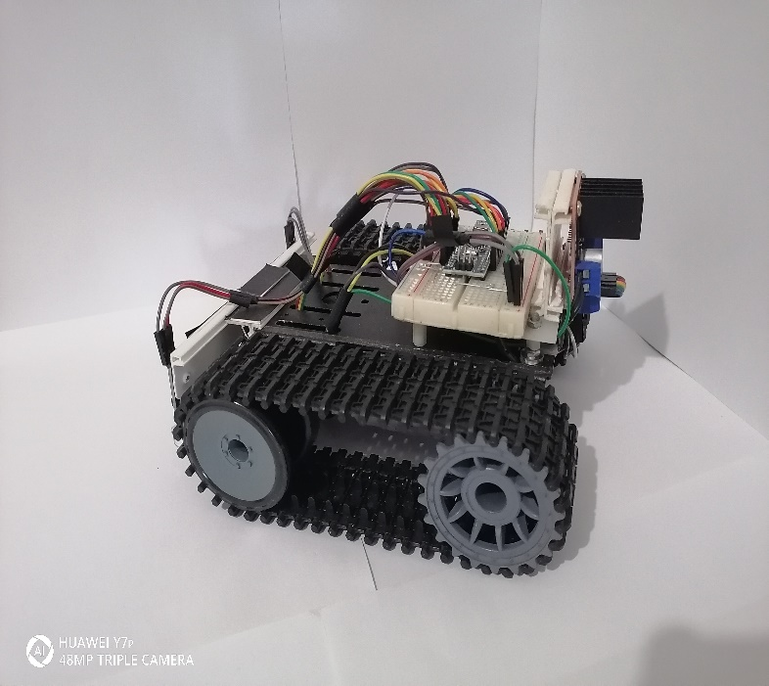

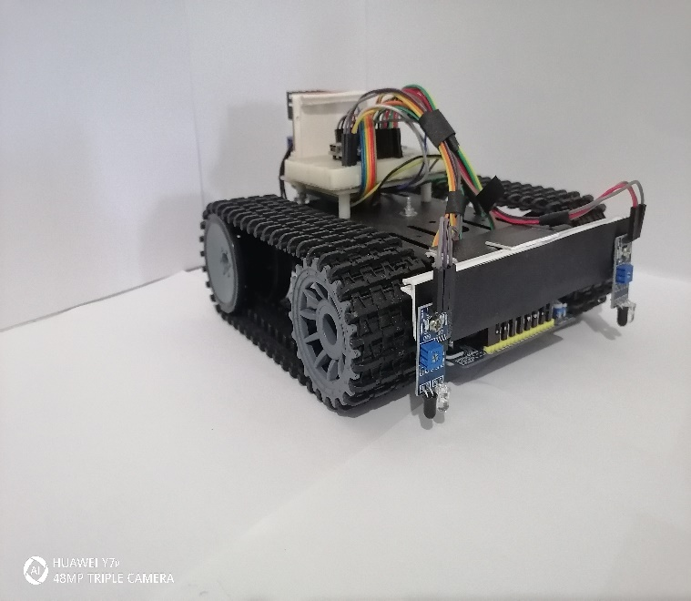
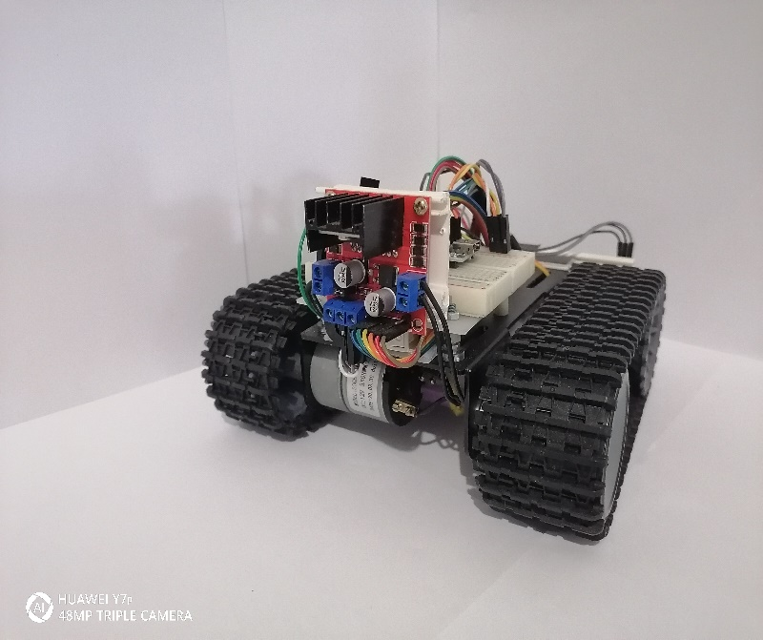

5.1.1 figure

5.1.3 figure 5.1.2 figure
5.2 Cost Estimation
S.N. | Particulars | Rate per items (Rs) | quantity | Total (Rs)
01 | Arduino nano | 780.00 | 1 | 780.00
02 | Sensor array | 1200.00 | 1 | 1200.00
03 | IR modules | 180.00 | 2 | 360.00
04 | Bread boards | 180.00 | 1 | 180.00
05 | Chassis | 5900.00 | 1 | 5900.00
06 | Motor Driver | 425.00 | 1 | 425.00
07 | li-po Battery | 8000.00 | 1 | 8000.00
08 | Switches | 20.00 | 1 | 20.00
09 | Jumper Wires | 280.00 | 1 | 280.00
10 | Miscellaneous |  |  | 2000.00
Total |  |  |  | 18983.00
5.2.1 table
5.3 References
https://en.wikipedia.org/wiki/PID_controller
https://www.youtube.com/channel/UCn_j4BdT8iAXn2-l5PcL5TQ
https://www.youtube.com/channel/UCa2lHajCato5iXUZ3WPE4Tw

APPENDICES
#include <BeeLineSensorPro.h>
#define M1p 4
#define M1n 5
#define M1pwm 10
#define M2p 2
#define M2n 3
#define M2pwm 9
#define Lsen 6
#define Rsen 7
#define Msen 11
BeeLineSensorPro sensor = BeeLineSensorPro((unsigned char[]) {
A0, A1, A2, A3, A4, A5, A6, A7
}, LINE_BLACK);

int M1sp = 160;
int M2sp = 160;

void setup() {
Serial.begin(115200);

pinMode(M1p, OUTPUT);
pinMode(M1n, OUTPUT);
pinMode(M1pwm, OUTPUT);
pinMode(M2p, OUTPUT);
pinMode(M2n, OUTPUT);
pinMode(M2pwm, OUTPUT);
pinMode(Lsen, INPUT);
pinMode(Rsen, INPUT);
pinMode(Msen, INPUT);
sensor.calibrate();
delay(2000);
digitalWrite(M1n, LOW);
digitalWrite(M1p, HIGH);
digitalWrite(M2n, HIGH);
digitalWrite(M2p, LOW);
analogWrite(M1pwm, 255);
analogWrite(M2pwm, 255);
delay(380);
mdrive(0, 0, LOW, LOW);
delay(10);
mdrive(255, 255, HIGH, LOW);
delay(330);
mdrive(0, 0, LOW, LOW);
delay(100);
sensor.calibrate();

}

int err = sensor.readSensor();
float kp = 0.85;
float kd = 0.7;
float ki = 0.5;
int last_value ;
int total_value ;

void mdrive(int m1, int m2, int p, int n) {

digitalWrite(M1n, p); //fowoad(sp1,sp2,HIGH,LOW)
digitalWrite(M1p, n); //backwoad(sp1,sp2,LOW,HIGH)
digitalWrite(M2n, p);
digitalWrite(M2p, n);
analogWrite(M1pwm, m1);
analogWrite(M2pwm, m2);
}

void linef() {

int err = sensor.readSensor();
int dff = err * kp + (err - last_value) * kd + total_value * ki;
last_value = err;
total_value = err;

if (dff > 0) {
if (dff > 95) {
dff = 95;
}
}

else {
if (dff < -95) {
dff = -95;
}
}
mdrive(M1sp + dff , M2sp - dff, HIGH, LOW);
}

int count;

void loop() {

sensor.calibrate();
int L = digitalRead(Lsen);
int R = digitalRead(Rsen);

if (L == 0 && R == 1 || L == 1 && R == 1 || L == 1 && R == 0) {
count++;
delay(100);
}

else {
count = count;
}

// Serial.println(count);
if (L == 0 && R == 1 && count == 5) {
mdrive(0, 0, LOW, LOW);
delay(10);
mdrive(255, 255, LOW, HIGH);
delay(150);
mdrive( 255, 0, HIGH, LOW);
delay(910);
mdrive(0, 0, LOW, LOW);
delay(10);
}
else if (L == 0 && R == 1 && count == 9) {
mdrive(0, 0, LOW, LOW);
delay(10);
mdrive(255, 255, LOW, HIGH);
delay(150);
mdrive( 255, 0, HIGH, LOW);
delay(910);
mdrive(0, 0, LOW, LOW);
delay(10);
}

else if (L == 0 && R == 1 && count == 15 || L == 1 && R == 1 && count == 15 || L == 1 && R == 0 && count == 15 ) {
mdrive(0, 0, LOW, LOW);
delay(10);
mdrive(255, 255, LOW, HIGH);
delay(150);
mdrive( 255, 0, HIGH, LOW);
delay(910);
mdrive(0, 0, LOW, LOW);
delay(10);
}

else if (L == 0 && R == 1 && count == 17) {
mdrive(0, 0, LOW, LOW);
delay(10);
mdrive(255, 255, LOW, HIGH);
delay(150);
mdrive( 255, 0, HIGH, LOW);
delay(910);
mdrive(0, 0, LOW, LOW);
delay(10);
}

else if (L == 0 && R == 1 && count == 23 || L == 1 && R == 1 && count == 23 || L == 1 && R == 0 && count == 23 ) {
mdrive(0, 0, LOW, LOW);
delay(10);
mdrive(255, 255, LOW, HIGH);
delay(150);
mdrive( 255, 0, HIGH, LOW);
delay(910);
mdrive(0, 0, LOW, LOW);
delay(10);
}

else if (L == 0 && R == 1 && count == 27) {
mdrive(0, 0, LOW, LOW);
delay(10);
mdrive(255, 255, LOW, HIGH);
delay(150);
mdrive( 255, 0, HIGH, LOW);
delay(910);
mdrive(0, 0, LOW, LOW);
delay(10);
}

else {
linef();
}

if(count>32){
mdrive(0, 0, LOW, LOW);
}

else {
linef();
}

}

